The pharmacy technician will use templates developed by the pharmacist team to assess for medication side effects, patient concerns with their medication, adherence issues and patient self-monitoring of their chronic medical conditions. Templates were created for asthma, COPD, diabetes, hypertension, lipids, smoking cessation and MTM. Based on patient response, the technician will schedule the patient with the pharmacist if needed according to the schematic below.

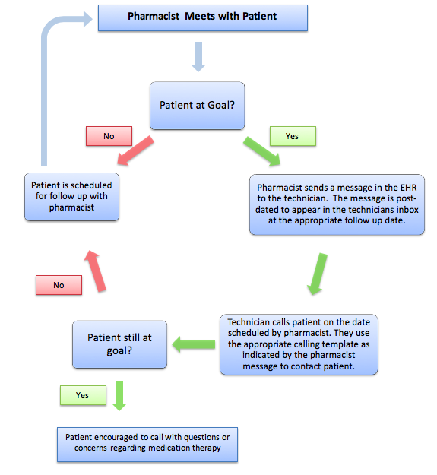

Pharmacy Technician Templates (1 - 7)
1. Asthma Follow Up
Do Asthma control test
Is the patient’s ACT total below 20?
If yes, recommend visit with the pharmacist

Is patient Risk Assessment Total greater than 0?
If yes, recommend visit with the pharmacist

{Insert Last ACT test results and date}

Do you have an albuterol rescue inhaler (Ventolin, ProAir, Proventil)?

How many times per week do you use your rescue inhaler? {1,2,3,4,5,6,7,8,9,10,***}
If 0-2 times per week, well-controlled. Appointment not necessary
If 3+ times per week, recommend visit with the pharmacist

Have you been hospitalized lately for an asthma attack?
If yes, recommend visit with the pharmacist

Do you feel like your inhalers are working well for your symptoms?
If no, recommend visit with the pharmacist

Do you have trouble affording your inhalers?
If yes, recommend visit with the pharmacist

2. COPD Follow Up

Do you have an albuterol rescue inhaler (Ventolin, ProAir, Preventil)?
If no, recommend visit with the pharmacist

How many times per week do you use your rescue inhaler? {1,2,3,4,5,6,7,8,9,10,***}
If 0-2 times per week, well controlled. Appointment not necessary.
If 3+ times per week, recommend visit with the pharmacist

Have you been hospitalized lately for COPD exacerbation?
If yes, recommend visit with the pharmacist

Do you feel like your inhalers are working well for your symptoms?
If no, recommend visit with the pharmacist

Do you have trouble affording your inhalers?
If yes, recommend visit with the pharmacist

3. Diabetes Follow Up

Patient’s last A1c: {Insert last A1c Results}

Has patient had an A1c done in the past 6 months?
If no, recommend a visit with the pharmacist

Is the patient at the A1c goal listed in the last pharmacy note?
If no, recommend a visit with the pharmacist

Do you test your blood sugars at home?

When do you test your blood sugars?

Have you been experiencing low blood sugars (less than 70mg/dL)?
If yes, recommend a visit with the pharmacist

Have you noticed your blood sugars increasing?
If yes, recommend a visit with the pharmacist

4. Hypertension Follow Up

{Insert last 3 blood pressures from the chart}

Was the most recent recorded blood pressure at the goal listed during the last pharmacy note?
If no, recommend a visit with the pharmacist

Do you check your blood pressure at home?

What have your blood pressures been over the past month?

Have there been any changes to your blood pressure medications since meeting with the pharmacist?
If yes, recommend a visit with the pharmacist

Have you noticed any abnormal dizziness/lightheadedness?
Is this bothersome to you or made you feel like you might fall?
If yes, recommend a visit with the pharmacist

5. Lipid Follow Up

{Insert last cholesterol values}

Are you still taking your cholesterol medication?
If no, recommend a visit with the pharmacist

Is the patient at the recommended statin intensity listed in the last pharmacist note?
High Intensity: Atorvastatin 40-80mg, Rosuvastatin 20-40mg
Moderate Intensity: Atorvastatin 10-20mg, Rosuvastatin 5-10mg, Simvastatin 20-40mg, Pravastatin 40-80mg, Lovastatin 40mg
Low Intensity: Simvastatin 10mg, Pravastatin 10-20mg, Lovastatin

If no, recommend visit with the pharmacist

Has the patient had their lipids checked in the past year?
If no, recommend a visit with the pharmacist

Have you noticed unusual muscle pain or weakness since starting cholesterol medication?
If yes, recommend a visit with the pharmacist

Have you had a heart attack, stroke or been diagnosed with heart disease since you last visit with the pharmacist?
If yes, recommend a visit with the pharmacist

6. Smoking Cessation Follow Up

Are you currently tobacco free?
If yes- congratulate patient- ask patient if they would like to meet with the pharmacist to discuss any other questions or concerns.

If no- Is patient still interested in quitting?
Would patient like to meet with the pharmacist to discuss other options to help quit smoking?

7. MTM Follow Up

Have you had a visit with your PCP in the last year?
If no, recommend a visit with the PCP

Have you had a hospitalization since your last visit with the pharmacist?
If yes, recommend visit with the pharmacist

Have you had changes to your medications that you are concerned or confused about?
If yes, recommend a visit with the pharmacist

Would you like to meet with the pharmacist to discuss your medications?
If yes, recommend a visit with the pharmacist

Is a visit with the pharmacist recommended for this patient?

{Enter any additional information the patient gave you during the call}

Total time spent with the patient {1,2,3,4,5,6,7,8,9,10,***}
Number of attempts to reach patient {1,2,3,4,5,6,7,8,9,10,***}

