Patient Care Services
Rapid Strep Testing Implementation
Service

Rapid strep testing in the community pharmacy performed by the pharmacist.

In states where prescriptive authority or collaborative practice agreements are allowed, this service also includes prescribing the appropriate prescription antibiotic if the test is positive for strep.

Prompt administration of antibiotic therapy and early amelioration of symptoms positively impacts patient quality of life:
- Shortens the duration of illness by 1-2 days
- Reduces rate of transmission
- Prevents secondary complications
- May reduce lost school and work days

Service Rationale

- Annually, approximately 15 million patients seek care for the relief of sore throat symptoms
- Many consult pharmacists first
- Access to primary healthcare provider may be limited or not available
- Traditional agar culture methods provide strep results in 24-48 hours
- Rapid strep testing results are available in minutes
- Strep throat background
  - Group A beta-hemolytic streptococcus
    - 30% of acute pharyngitis in children
    - 10% of acute pharyngitis in adults
    - Peak incidence 4-14 years of age
    - Late fall-spring
    - Generally self-limited (7 days)
    - Only form where antibiotic treatment indicated
  - Upper respiratory tract viruses
    - >50% of acute pharyngitis cases
- Prevent strep throat complications
  - Suppurative complications
    - Peritonsillar abscess
    - Otitis Media
    - Sinusitis
  - Immunologic complications
    - Acute rheumatic fever
      - Endemic incidence = 0.3%
      - After strep epidemic = 3.0%
      - Onset 14 to 35 days p Strep infection
      - PCN within 9 days of symptom onset prevents rheumatic fever
    - Post-streptococcal glomerulonephritis

Goals
- Provide timely, cost effective access to rapid strep testing
- Offer immediate antibiotic therapy to patients who test positive thereby shortening the clinical course of the illness
- Provide comprehensive counseling about proper administration of antibiotic regimen, side effects
- Educate parents/patients about strep throat and discuss not all sore throats require antibiotics
- Prevent secondary complications associated with strep throat (i.e. rheumatic fever, otitis media, sinusitis)
- Minimize or prevent the occurrence of adverse effects of antimicrobial therapy
- Reduce antibiotic resistance through proper antibiotic use, selection, and patient follow-up that encourages adherence
- Facilitate communication and teamwork between the pharmacy and patient’s healthcare practitioner
- Develop a profitable niche service
- Enhance the reputation of the community pharmacist as a provider of clinical services

Preliminary Education

- Each of the following resources are valuable when preparing the pharmacists to become proficient and successful in offering this service. The one resource which is a must is the “primer on community-based rapid antigen testing for strep throat” listed immediately below.
- National Community Pharmacists Association (NCPA)
  - ACPE credentialing program, “A primer on community-based rapid antigen testing for strep throat.” Program #207-999-02-163-H01. [www.ncpanet.org] Alexandria, VA; 2002.
  - www.ncpanet.org
  - 1-800-544-7447
- Practice guidelines for the management of Group A streptococcal pharyngitis. Clin Infect Dis. 2002;35:113-25.
- Practice guidelines for the judicious use of antibiotics, acute pharyngitis. Washington State Department of Health and the Washington State Medical Association.

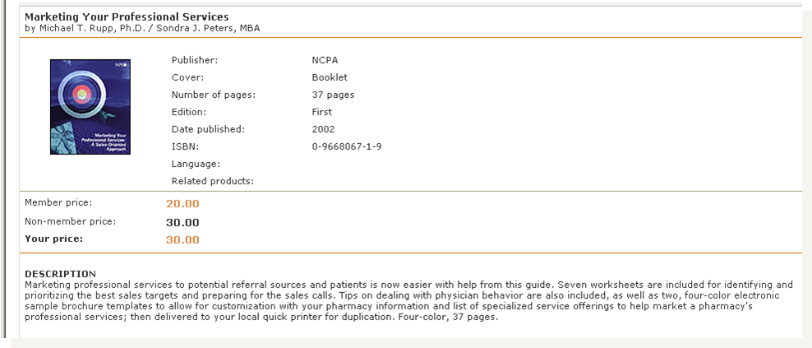

Preparation: Financial Analysis

Market Analysis
- Determine market potential
- Identify competitors
- Identify potential collaborators
- Identify potential referral sources
- Identify target markets
  - Pharmacy staff
    - Professional staff
    - Ancillary staff
  - Current customers
  - Potential patients
  - Health care providers
  - Community

Financial Proforma
- Determine expenses
- Determine revenue
- See Appendix Five: Proforma Revenue/Expense Template
- See Appendix Six: Break even Analysis for a Professional Service (developed by Mike Rupp, Midwestern University)
- Determine financial viability
  - Is this a service which will contribute to the business bottom line?
  - Is this a service which will contribute to an enhanced professional reputation for the pharmacists/pharmacy?
  - Is this a service which will drive an increased number of consumers to the pharmacy, ultimately contributing to an increased number of patients to whom the business can market?
  - Is this a service which is aimed at our target market?
  - Is this a service which is in keeping with the pharmacy mission?

Preparation: Personnel and Operations

Develop documents
- Build a collaborative agreement if allowed in your state
- Identify MD for collaborative agreement
- Outline purpose of service
- Pharmacist training (practice guidelines, in-service)
- Updating CLIA-waived status to include test
- Patient selection criteria
- Testing & examination supplies and procedures
- Procedure if test is positive or negative
- Antibiotic selection, OTC recommendations
- Documentation
- Review of records and feedback by physician
- Term of agreement & signatures
- Submit to State Board of Pharmacy
- See Appendix One: Collaborative Practice Agreement

Secure supplies
- Acceava was chosen because it is currently being used in the labs and physician’s offices in the Washington communities where this service was established. We believed this would enhance acceptance, reassuring other health professionals that a quality, reliable test was used.
- Acceava testing products can be secured from medical supply wholesalers at an approximate cost of $25.00/box of 10 tests.
- Acceava information
- See Appendix Seven: Supplies Used for Rapid Strep Testing
- See Appendix Nine: Acceava Brochure

Professional staff training
- Pharmacists should complete the NCPA ACPE credentialing program, “A primer on community-based rapid antigen testing for strep throat.”
- See Appendix Eight: Obtaining a Sample and Performing a Rapid Strep Test
- See Appendix One: Collaborative Practice Agreement
- Another strategy that works well is to have the collaborating physician conduct a physical assessment session to ensure competence in assessing the glands and obtaining an accurate swab.

Ancillary staff training
- Hold a store meeting to educate all ancillary employees (technicians, assistants, clerks, sales persons, delivery persons, office staff, etc) about the value of this service to the pharmacy patrons. Emphasize the advancements in practice this service innovation represents.

Legal and regulatory issues
- Ensure that the collaborative practice protocol is executed properly and filed with the appropriate agency (Board of Pharmacy).
- Keep your insurance agent apprised of changes, expansions, and innovations in practice.

Work space/ Work flow
- Determine where this service will be offered (private office or at a desk in an alcove, etc.).
- Determine where supplies will be stored.
- Determine where the patient records will be kept and how they will be organized.

Counseling/ education/ consent materials
- Develop or secure patient materials which will reinforce the pharmacist’s educational message.
- See Appendix Four: Patient Educational Materials

Documentation and billing
- See Appendix Two: Screening Tool and Patient Evaluation
- See Appendix Three: Follow-up Documentation
- Determine if this service will be a cash only or a billable service to a third party payer.
- Determine how and where patient folders will be stored.

Determine follow- up procedures
- See Appendix Three: Follow-up Documentation

Marketing plan development and implementation
- Selling
- Advertising
- Special promotions
- Outreach marketing
- Media
- Networking
- Merchandising
- Spin-offs

Establish patient session guidelines
- Patient session guidelines
  - Patient data collection
  - Patient assessment and drug therapy assessment
  - Pharmacist care plan
  - Patient care evaluation
  - Documentation
- Train each pharmacist to cover the same topics to ensure consistency and quality

Enroll patients
- Not applicable to this service implementation.

Implementation

Establish payment mechanisms
- Cash
- Determine how much to charge for this service by determining the break even point. See Appendix Six: Break even analysis for a professional service (developed by Mike Rupp, Midwestern University)
- Will you establish a relationship with an insurer to be able to bill this encounter, using a CPT professional service code to bill the third-party payer?

Patient encounter documents
- See Appendix Two: Screening Tool and Patient Evaluation

Patient follow up procedures
- The pharmacist will call/e-mail the patient or parent within the first 4 days of therapy to assess adherence, improvement in symptoms, possible side effects, and answer questions the patient or parent(s) may have.
- Each pharmacist will document his or her patient assessment and strep test result using the standard documentation form, “Acute Pharyngitis Evaluation”.
- A copy of the documentation form will be sent to the patient’s primary healthcare provider within 48 hours if patient authorizes.
- The pharmacist will also notify the provider of necessary information obtained during the follow-up phone call if therapy is compromised.
- See Appendix Three: Follow-up Documentation

Evaluation and Continued Quality Improvement

Quarterly Evaluation
- Track the number of evaluations performed
- Track the number of actual tests performed
- Track the results, positive and negative
- A chart or excel spreadsheet as illustrated below can be used to track this information
- The information tracked can help determine what adjustments need to be made (additional advertising, marketing to health professionals, education of ancillary personnel to increase awareness of service, etc)

2008 Quarter 3
XXX Pharmacy
 |  | Number
Test Performed | Yes
Test Performed | No
Age | <18 yo
Age | > 18 yo
Gender (Child) | Male
Gender (Child) | Female
Gender (Adult) | Male
Gender (Adult) | Female
Test Result | Positive
Test Result | Negative
Supportive Care | Yes
Supportive Care | No
Adult Antibiotic | Yes
Adult Antibiotic | No

Annual Assessment
- Determine improvements which are necessary
- Survey a sampling of patients to determine satisfaction and improvements needed
- Evaluate the quarterly reports to assure proper patient follow up is in place

Keys to Success

- Strive to provide innovative services that meet your communities need
- Be organized and manage your time well
- Delegate as needed
- Network & market with other healthcare providers
- Communicate, reevaluate, approach from various angles

Contacts

Linda Garrelts MacLean, Pharmacist, Certified Diabetes Educator
Chair and Clinical Associate Professor
Department of Pharmacotherapy
College of Pharmacy
Washington State University
PO Box 1495
Spokane, WA 99223
Office phone: 509-358-7732
Email: lmaclean@wsu.edu

Catrina Schwartz, PharmD
Clinical Assistant Professor
Department of Pharmacotherapy
College of Pharmacy
Washington State University
PO Box 1495
Spokane, WA 99223
Office phone: 509-358-7670
Email: crschwartz@wsu.edu
And
Jones Pharmacy
South 906 Monroe
Spokane, WA 99204
Office phone: 509-838-6451

Holly Whitcomb Henry, Pharmacist
President
Rxtra Care, Inc.
7317 - 35th Avenue NE
Seattle WA 98115
Office phone: 206-417-8066
Email: hollyhenry@rxtracare.net

Appendices

Appendix One: Prescriptive Authority Protocol
Appendix Two: Screening Tool and Patient Evaluation
Appendix Three: Follow-Up Documentation
Appendix Four: Patient Educational Material
Appendix Five: Pro Forma Income/Expense Template
Appendix Six: Break Even Analysis for a Professional Service
Appendix Seven: Supplies Used for Rapid Strep Testing
Appendix Eight: Obtaining a Sample and Performing a Rapid Strep Test
Appendix Nine: Acceava Brochure

