


Impact of Community Pharmacist-Provided Enhanced Patient Care Services in a Medicaid Population
Salvati S, McGrath S, Kirisci L, Bhosle M, and Coley KC
University of Pittsburgh School of Pharmacy | Pittsburgh, PA

Objectives
- The primary objective of this study was to evaluate the impact of pharmacist-provided patient care services as part of a Medicaid Managed Care Organization (MCO) payor contract on metrics including medication adherence, naloxone dispensing, and COVID-19 vaccination gap closure.
- The secondary objective was to develop a Resource Guide to facilitate analyses of Pharmacist eCare Plan data (PeCP) with claims data.
Methods
Design | - This was a quasi-experimental, before/after study evaluating deidentified PeCP data with linked deidentified claims data of patients participating in a Medicaid MCO payor program.  - Medication Adherence  - The payor program included four adherence services: medication synchronization, medication reconciliation, medication adherence packaging, and medication home delivery.  - Patient medication adherence was measured and compared before and after the initiation of the payor program using two-time periods; a baseline (August 1, 2020, through July 31, 2022) and intervention period (August 1, 2022, and December 31, 2023). The intervention period was when PPCN pharmacists were providing medication adherence services as part of the payor program.  - Subjects were Medicaid patients who received (1) at least one of the four pharmacist-provided medication adherence services during the intervention period, (2) at least two prescription fills of at least one of the targeted medication classes during the intervention period, and (3) at least two prescription fills of the corresponding medication class(es) during the baseline period.  - Targeted medication classes for this study were Renin Angiotensin System Antagonists (RASAs), HMG-CoA Reductase Inhibitors (Statins), and noninsulin diabetic medications (NIDMs).  - Naloxone dispensing and education and COVID-19 vaccine closures were analyzed using descriptive statistics.  - To develop the Resource Guide data was compiled from project team meeting notes, electronic communications between all partners, and journal notes detailing data management and analysis. The Guide was also reviewed by outside experts for content, clarity, flow, and useability.
Study endpoints | - Changes in Proportion of Days Covered (PDC) Scores (Medication Adherence) for RASAs, Statins, and NIDMs.  - Quantity of pharmacist-provided naloxone education and dispensing services and COVID-19 vaccine gap closures.
Results
- Adherence
  - There were 1,361 total Medicaid patients that met inclusion criteria for the adherence analyses.
  - Overall, average PDC scores across all three drug classes increased significantly during the intervention period when patients were receiving pharmacist-provided adherence services.
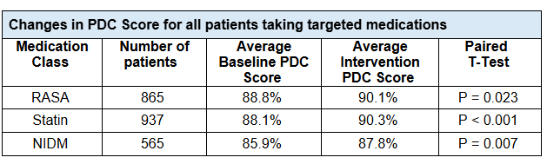
  - The sub-analysis showed average PDC scores among nonadherent patients significantly increased across all three drug classes during the intervention period.
- There were 536 naloxone education and dispensing services provided to 425 unique patients across 48 unique pharmacies.
- There were 630 COVID-19 Vaccine Gap Closures for 579 unique patients across 60 unique pharmacies.
- The Resource Guide is provided as a separate attachment.
Conclusion
- This study demonstrates Medicaid patient adherence significantly improved while receiving community pharmacist provided adherence services as part of a Medicaid MCO payor program.
- Pharmacists were able to provide and be reimbursed for both naloxone and COVID-19 vaccine services through this payor program.
- There is value in obtaining claims data from payors to evaluate community pharmacy-based programs. The development of a Resource Guide explaining this process may be used by other pharmacy networks to evaluate their own programs and demonstrate the value of pharmacist services.

