FREE Blood Pressure and

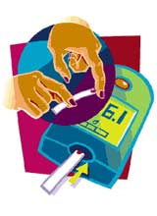
Diabetes Counseling



Kerr Drug is recruiting participants for a study to evaluate the effectiveness of individualized counseling on the management of blood pressure or diabetes

Participants will be required to visit with the pharmacist 3 times over the next 3 months

Participants will receive:
- Medication reviews
- Blood pressure monitoring
- Weight assessment
- Blood sugar assessment
- Omron® blood pressure monitor or blood sugar meter

If interested, please call (XXX) XXX-XXXX or stop by the Kerr Health Care Center

